

MAPÚA MALAYAN COLLEGES MINDANAO

Easy-E: A C# Windows-Forms Event Management System for Multi-Day Events at MMCM

By

Basil Ralph A. Birondo

Julian A. Tandug

A Research Synopsis in Partial Fulfillment of the Requirements for the IT102: Object Oriented Programming

Bachelor of Science in Information Systems

Engr. Martzel Baste

Course Instructor

Introduction

Background of the Study
MMCM regularly organizes educational seminars, workshops, and conferences that span multiple days. Currently, attendance tracking and event management rely on manual sign-in sheets, spreadsheets, or multiple disconnected tools. These manual processes are time-consuming and prone to errors, making it difficult to produce reliable attendance reports or certificates in a timely manner.
Recent research has highlighted significant challenges in traditional attendance tracking methods at educational institutions. Chowdhury and Rahman (2024) found that manual attendance systems in universities are characterized by time-consuming processes, high error rates, and limited ability to provide real-time insights into student engagement patterns. Similarly, comprehensive studies on university event management reveal that fragmented communication, high administrative demands, and limited data-driven insights hinder effective event organization and student engagement.
A dedicated desktop application tailored for multi-day events would help organizers capture daily attendance accurately, manage schedules, and generate required reports efficiently. Research by Srivastava (2025) demonstrates that technology-driven event management solutions can significantly improve operational efficiency, reduce manual errors, and enhance participant tracking capabilities. This project will be implemented in C# using Windows Forms for the user interface and a MySQL relational database for data storage, following established best practices for desktop application development with database integration.
The event management software market has experienced substantial growth, with projections indicating significant expansion driven by increasing demand for automation, real-time data processing, and comprehensive event tracking solutions. This market trend validates the need for specialized event management systems in educational institutions.

Sustainable Development Goals (SDG) Alignment
The proposed project, Easy-E: A C# Windows-Forms Event Management System for Multi-Day Events at MMCM, aligns with several Sustainable Development Goals (SDGs) by promoting efficiency, organization, and inclusivity in educational event management. By automating registration, attendance tracking, and reporting, the system enhances institutional processes and supports the effective use of resources within the academic community.
SDG 4: Quality Education
Through improved management of seminars, trainings, and workshops, Easy-E contributes to the enhancement of educational experiences and learning outcomes. Accurate participant registration and systematic attendance tracking enable organizers to monitor engagement and ensure effective implementation of educational programs. Research by Aunzo (2025) highlights that the integration of educational technology plays a crucial role in achieving SDG 4 by improving access, quality, and resource efficiency in learning environments.
SDG 11: Sustainable Cities and Communities
At the community level, Easy-E supports sustainable campus and local development by promoting organized, well-managed events. Efficient scheduling, real-time reporting, and resource monitoring lead to safer and more coordinated gatherings. These improvements foster collaboration, strengthen community engagement, and align with SDG 11’s goal of building inclusive, resilient, and sustainable communities through the responsible use of institutional resources.

Statement of the Problems
● What problems arise from using manual processes in managing events and attendance in school settings?
Educational institutions continue to experience inefficiencies in traditional event and attendance tracking systems. Manual recording of participant details, attendance logs, and event schedules often results in data errors, duplication, and time-consuming documentation. Studies show that manual attendance systems have error rates ranging from 1–3% and require considerable staff time to correct inaccuracies (Organ, 2024; SoftDunamis, 2025; Attendly, 2024). Similarly, event registration processes become complex due to inconsistent documentation, technical issues, and miscommunication among organizers (Engagifii, 2024; EventX, 2025).
● Who are the users affected by these issues, and how do these problems impact their workflow?
Event organizers, administrative staff, and participants are directly affected by these challenges. Staff spend excessive time consolidating paper-based data, verifying attendance lists, and preparing post-event reports. These repetitive tasks increase human error, delay report generation, and make event coordination less efficient. Participants also face registration delays and poor communication due to disorganized tracking systems. Meanwhile, administrators lack timely and accurate data to assess participation and engagement levels across multiple events (IJARCCE, 2024; Classter, 2025).
● Where in the current operations are these problems most evident?
The problems are most evident during the registration and attendance tracking phases of multi-day events, seminars, and workshops. Manual documentation creates challenges in updating attendance sheets, monitoring real-time participation, and generating accurate reports. Additionally, the absence of an automated system makes it difficult to consolidate records, analyze event data, and provide quick certification or reporting outputs. These inefficiencies disrupt institutional workflow and hinder effective event management at MMCM.

Objectives of the Study

- Objective 1: Multi-Day Event Creation and Scheduling
To design and implement a module that enables organizers to create multi-day events with detailed information, including date, time, and venue. This feature ensures proper event organization, prevents scheduling conflicts, and provides a structured timeline for both participants and administrators.

- Objective 2: Attendance Capture and Data Management
To provide an attendance management module capable of recording daily attendance through manual entry. This functionality ensures flexible data input, reduces manual errors, and maintains accurate records for large-scale events and training sessions.

- Objective 3: User Role and Access Control
To implement a role-based access system defining three user types—Administrator, Organizer, and Viewer—each with specific permissions. This ensures data security, proper task delegation, and efficient management of event-related responsibilities.

- Objective 4: Application of Object-Oriented Programming Principles
To apply object-oriented programming concepts such as encapsulation, inheritance, and polymorphism in the system’s design and implementation. The user interface will be connected to a MySQL or MSSQL database to enable full Create, Read, Update, and Delete (CRUD) operations across all system entities.

Conceptual Framework
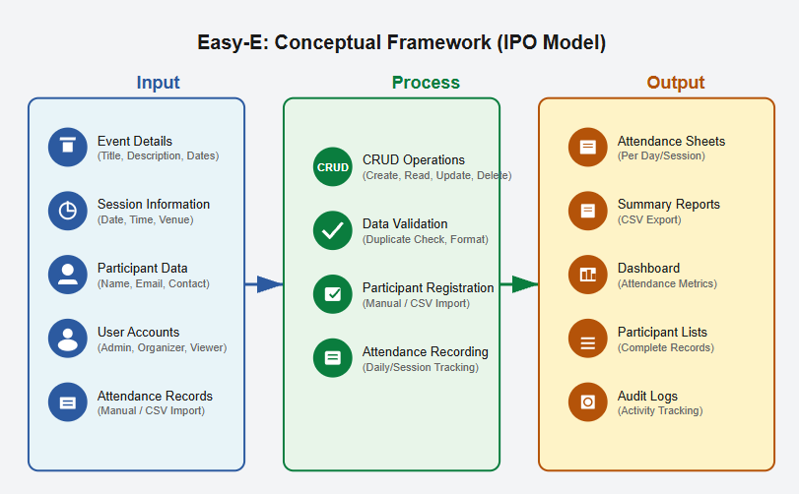

Target Market / Users
The proposed system primarily targets MMCM event organizers and administrative staff who manage seminars, workshops, and multi-day institutional events. By automating event creation and attendance tracking, Easy-E minimizes manual workload and reduces errors. Secondary users include student organizations, faculty coordinators, and external partners who will benefit from improved coordination and data accessibility. Event participants also gain from a smoother registration and attendance process, as the system ensures accurate and accessible records for organizers and participants. Overall, Easy-E enhances efficiency, accuracy, and convenience for all stakeholders involved in MMCM’s event management process.

Similar Applications
Features / Criteria | Eventbrite / Ticketing Platforms | Google Forms & Sheets | Campus / University Custom Systems | Easy-E (Proposed System)
Online Registration | ✔️ | ✔️ | ✔️ | ✔️
Offline Capability | ❌ | ❌ | ❌ | ✔️
Free to Use | ❌ (fees may apply) | ✔️ | ❌ | ✔️
Tailored for MMCM Workflows | ❌ | ❌ | ✔️ (partially) | ✔️
Automated Certificate Generation | ❌ | ❌ | ✔️ | ✔️
Role-Based User Control | ✔️ (limited) | ❌ | ✔️ | ✔️
Requires Internet Connection | ✔️ | ✔️ | ✔️ (mostly) | ❌
Ease of Use | ✔️ | ✔️ | ❌ (complex) | ✔️
Report Generation | ✔️ (basic) | ❌ | ✔️ | ✔️
Integration with Institutional Systems | ❌ | ❌ | ✔️ | ✔️ (future-ready)
Maintenance Cost / Complexity | ❌ (subscription-based) | ✔️ (low) | ❌ (high) | ✔️ (low)

Scope and Limitations
The proposed Easy-E: A C# Windows-Forms Event Management System is a desktop-based application specifically developed for Mapúa Malayan Colleges Mindanao (MMCM) to automate and centralize multi-day event management. The system focuses on core functionalities such as creating and managing events, registering participants, capturing attendance through manual input and managing participant records. It also implements a role-based access system with user classifications such as Administrator, Organizer, and Viewer to ensure proper task delegation and data security. Built using C# and Windows Forms, the system applies object-oriented programming principles and connects to a relational database for seamless CRUD operations. Through these features, Easy-E aims to enhance efficiency, accuracy, and organization in managing academic and institutional events within MMCM.
However, the system is limited to desktop use and does not include a mobile or web version. It does not integrate with biometric or RFID devices for attendance tracking and operates solely on a local database without cloud synchronization. Additionally, Easy-E does not yet support integration with the institution’s single sign-on (SSO) system and is limited to generating basic analytical reports without advanced machine learning or predictive capabilities. Future updates may address these limitations to further expand system functionality and accessibility.

METHODOLOGY

Research Design
This study employs a developmental and descriptive research design aimed at designing, implementing, and evaluating a desktop-based event management system for Mapúa Malayan Colleges Mindanao (MMCM). The study is developmental because it focuses on creating a functional software solution that addresses the specific operational challenges of managing multi-day academic events. It is descriptive as it systematically documents the design process, system architecture, functionalities, and testing outcomes to evaluate its effectiveness in improving event coordination and attendance tracking.
The research follows the Systems Development Life Cycle (SDLC) approach, which includes the stages of requirements analysis, system design, development, testing, and deployment. This structured methodology ensures that the system meets both functional and non-functional requirements while maintaining usability, performance, and scalability within MMCM’s academic environment.
System Development Environment
The Easy-E Event Management System is implemented as a C# Windows Forms desktop application using Visual Studio as the integrated development environment (IDE). The system utilizes MySQL as its relational database for efficient storage, retrieval, and management of event and attendance data. GitHub serves as the version control platform to ensure collaborative and organized code management.

Rationale for Technology Choices
- C# provides robust object-oriented programming capabilities and seamless integration with the Windows operating system, making it ideal for developing desktop applications that require offline functionality.
- Windows Forms offers a user-friendly graphical interface and supports event-driven programming, simplifying interaction between the user and the system.
- MySQL is lightweight, reliable, and scalable, ensuring efficient database performance for storing events, participants, and attendance data.
- Visual Studio provides comprehensive development tools, debugging support, and GUI design features, streamlining the creation of the application.
- GitHub facilitates version tracking, collaboration, and project documentation throughout the development process.
Project Definition (Framework, Programming Language, and Libraries Used)
The Easy-E: Event Management System was developed using modern Microsoft technologies and open-source tools to ensure efficiency, maintainability, and scalability. The system’s architecture was designed to meet the functional requirements of MMCM’s event management processes while maintaining simplicity and offline accessibility. This section outlines the core technologies, programming language, development frameworks, and tools used in building the application. Each component was carefully selected to provide seamless integration between the graphical interface, business logic, and database layer, ensuring a stable and user-friendly desktop-based system.

Programming Language
- C#
C# serves as the primary programming language due to its structured syntax, support for object-oriented programming, and built-in features for desktop application development. Its reliability and integration with Windows Forms make it an excellent choice for local event management systems.

Framework
- Windows Forms
Windows Forms provides the core structure for building graphical interfaces, enabling interactive forms such as Login, Event Dashboard, Attendance Tracker, and Reports. It follows an event-driven architecture, allowing the program to respond dynamically to user interactions like button clicks or form submissions.

Database
- MySQL
The system employs a relational database to manage interconnected data entities such as Events, Participants, Users, and Attendance Records. MySQL ensures data consistency through foreign key constraints and provides fast query execution for CRUD operations.

Development Tools
- IDE: Visual Studio (latest version)
- Version Control: GitHub

OOP and GUI Implementation Details
Encapsulation
Encapsulation in this system is demonstrated by grouping related data and methods within specific classes while restricting direct access to internal data. Classes such as Event, Participant, and User contain private fields that cannot be accessed directly by external classes. Instead, public getter and setter methods are provided to safely read or modify these fields. For example, the EventTitle attribute is declared as private, and methods like GetEventTitle() and SetEventTitle() are used to retrieve or update its value. This ensures that the internal state of each object is protected, data integrity is maintained, and any modifications occur only through controlled interfaces—one of the core principles of object-oriented programming.

Inheritance
Inheritance is applied by creating a base User class that defines shared properties and methods for all system users. Subclasses such as Administrator, Organizer, and Viewer inherit from this base class, gaining access to its fields and functions without rewriting code. Each subclass extends the functionality of the base User class to match its assigned system role. For instance, the Administrator class is capable of managing users and event data, the Organizer can oversee participants, and attendance records, while the Viewer is restricted to read-only access. This structure promotes code reusability, consistency, and scalability, allowing future roles to be added without major code restructuring.

Polymorphism
Polymorphism is demonstrated through method overriding, where shared methods behave differently depending on which class calls them. For example, the method DisplayDetails() outputs varying information based on the object instance—Event.DisplayDetails() displays event details, while Participant.DisplayDetails() shows participant information. This flexibility allows the same method name to perform distinct functions depending on the context, thereby improving code readability and reusability. By using both compile-time and runtime polymorphism, the system remains adaptable to future modifications and extensions.

Abstraction
Abstraction is implemented by designing classes that expose only the essential features of the system while concealing complex implementation details. For example, the DatabaseManager class abstracts CRUD operations, allowing other classes to interact with the database using simple methods such as InsertRecord(), UpdateRecord(), and DeleteRecord() without exposing SQL queries or database logic. This separation simplifies development, enhances maintainability, and allows for easier debugging and updates. Through abstraction, the system maintains a clean architecture where each class has a specific role—promoting modularity and efficient communication between components.

Graphical User Interface (GUI) Implementation
The Easy-E Event Management System interface is developed using Windows Forms to provide a clear, organized, and user-friendly experience. The GUI is designed to streamline the workflow of event organizers and administrative staff while remaining intuitive for all user roles, including viewers and participants. Each form follows an event-driven programming model, meaning the system responds dynamically to user interactions such as button clicks, data entries, and form selections. Navigation between forms is achieved through commands like FormDashboard.Show(); and this.Hide();, allowing smooth transitions between different modules of the system.

Key GUI design features include:
● Windows Forms Controls
The interface utilizes common Windows Forms components such as DataGridView for displaying records, ComboBox for selection lists, TextBox for data input, and DateTimePicker for scheduling events and sessions. These controls ensure efficient interaction between users and the system, allowing for quick data manipulation and visualization.

● Event-Driven Structure
The system’s design centers around event handling, where user actions trigger specific methods or responses. For example, clicking a button may open a form, save data to the database, or display an event list. This approach ensures smooth workflow and immediate system feedback during data entry or record updates.
● Form-Based Navigation
Navigation within the application is implemented using multiple interlinked forms that correspond to different system modules. Major forms include the Login Form (for user authentication), Dashboard Form (for general navigation and overview), Event Form (for event creation and editing), Session Manager (for managing schedules and sessions), Attendance Form (for recording attendance manually), and Reports Form (for generating and exporting attendance summaries and participation certificates).
● User-Centric Design
The interface prioritizes usability and clarity through organized layouts, readable fonts, and consistent color schemes. Each form includes labeled buttons, validation prompts, and structured panels to guide users through the system efficiently. The design ensures that even first-time users can easily understand how to perform essential tasks like creating events, marking attendance, or exporting reports.

Database Schema and ERD
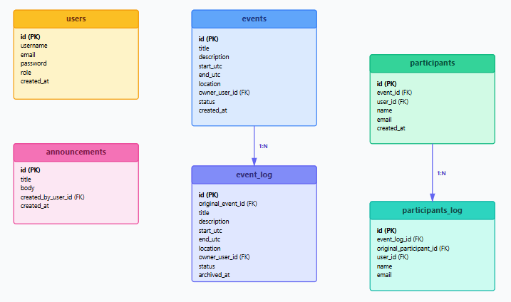

CRUD Functionalities
Entity | Create (C) | Read (R) | Update (U) | Delete (D)
Event | Add new events with title, date, and description | View event list | Edit event details | Remove outdated events
Participant | Register new participants | View participant profiles | Update contact details | Delete records
Attendance | Record attendance manually | View attendance per event | Edit incorrect entries | Delete records
User | Create new user accounts | View user list | Update user roles | Delete inactive users

System Prototyping Screenshots

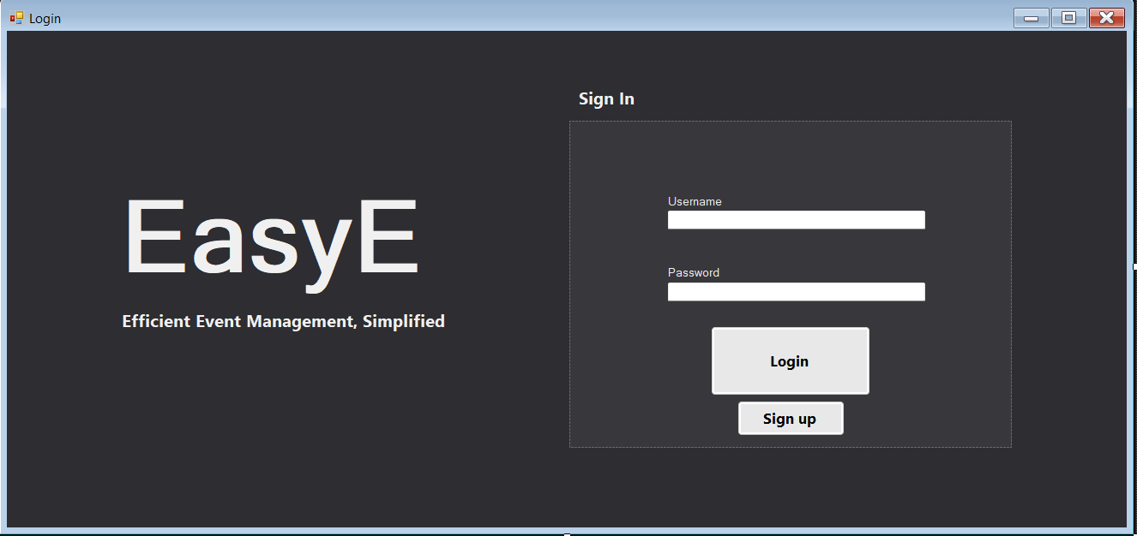

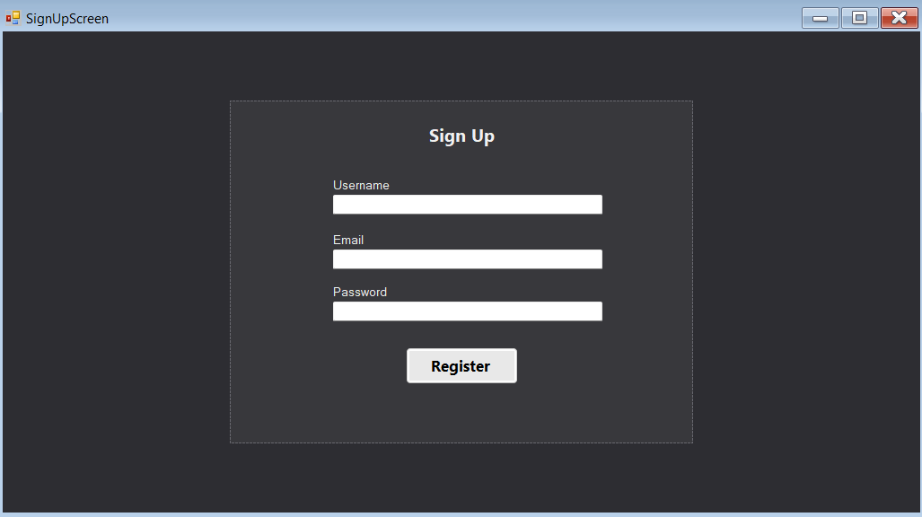
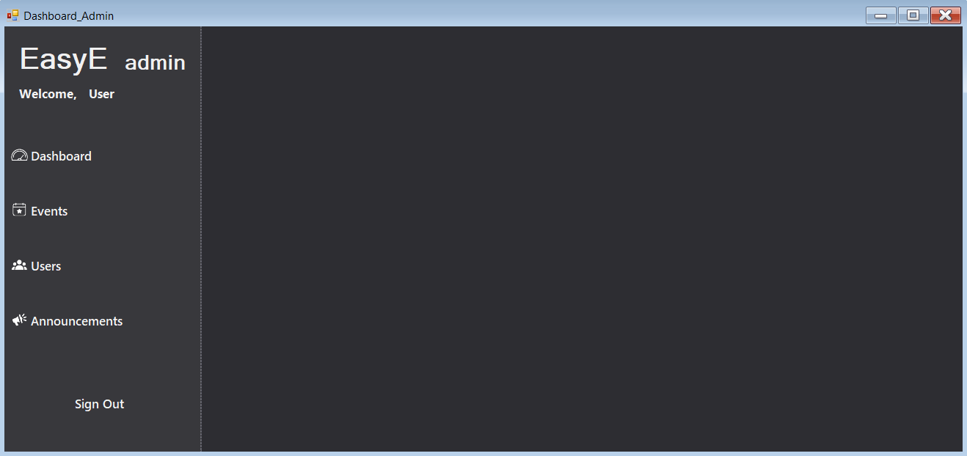
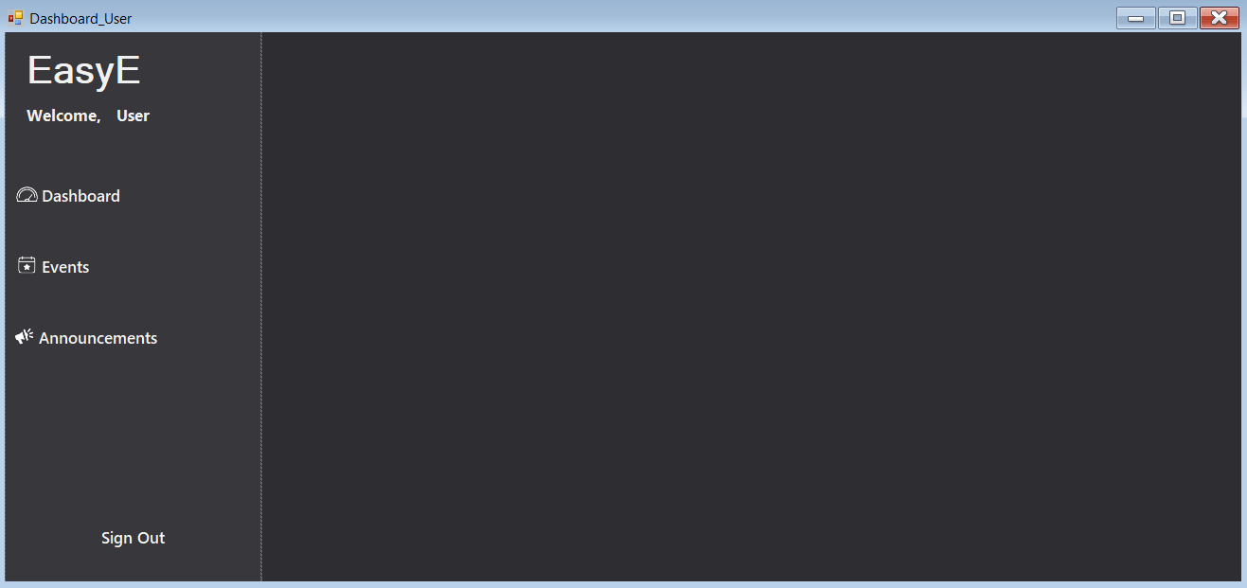

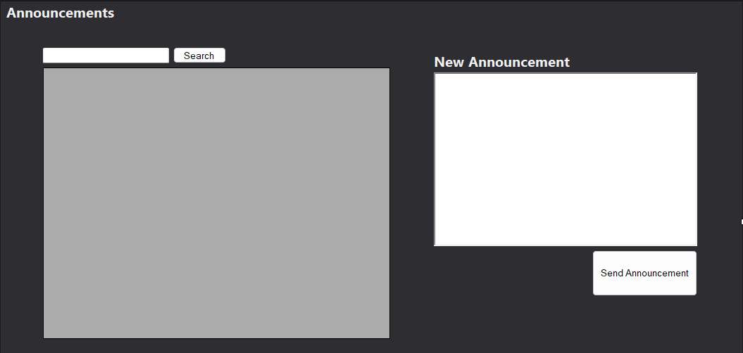
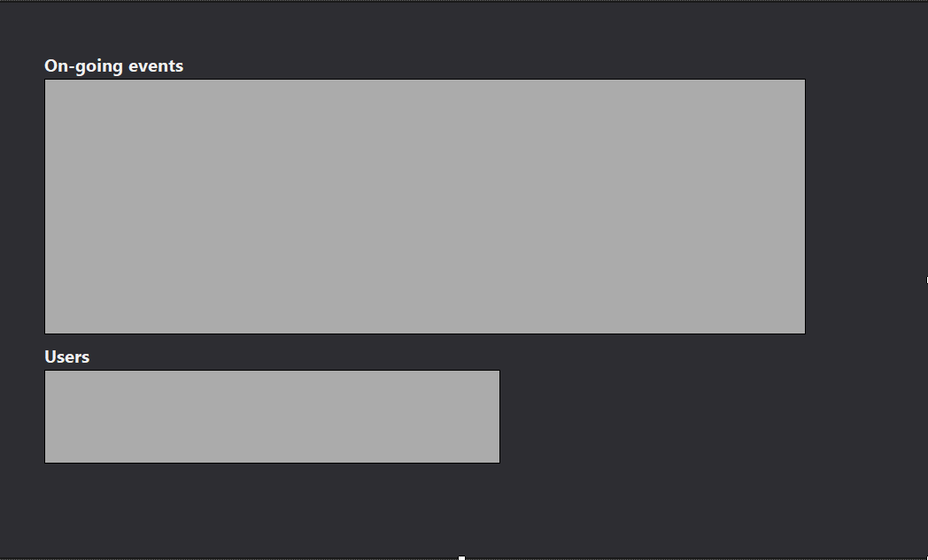
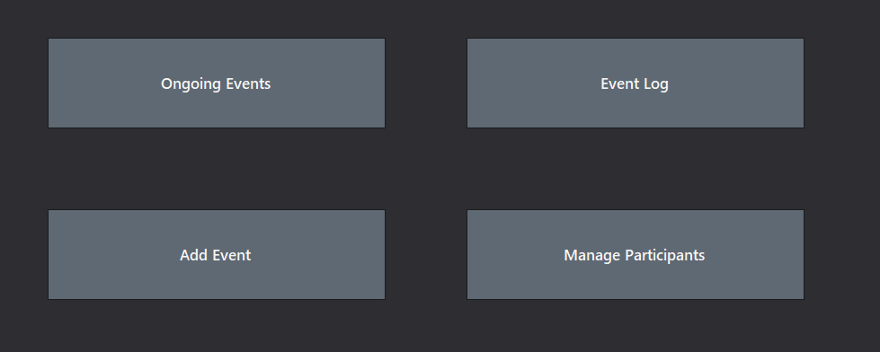

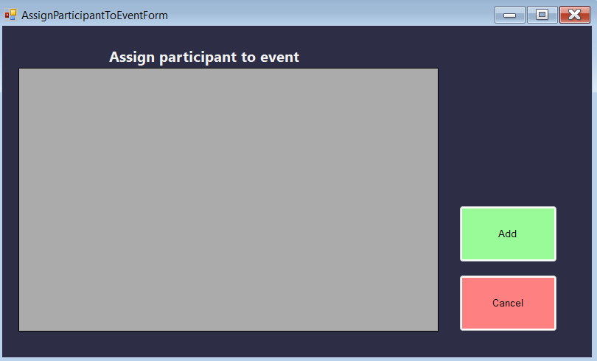

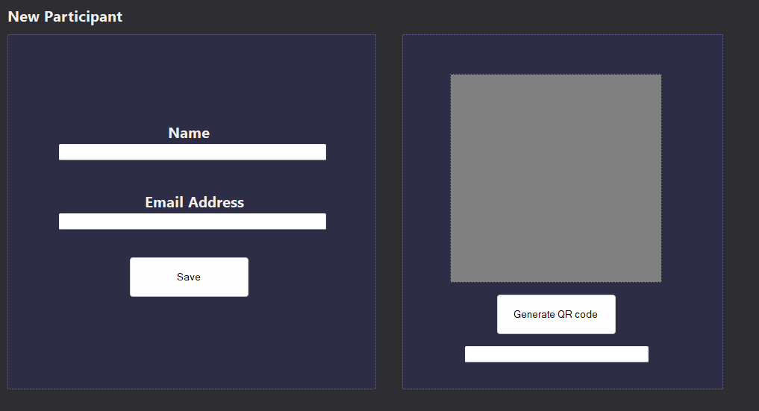

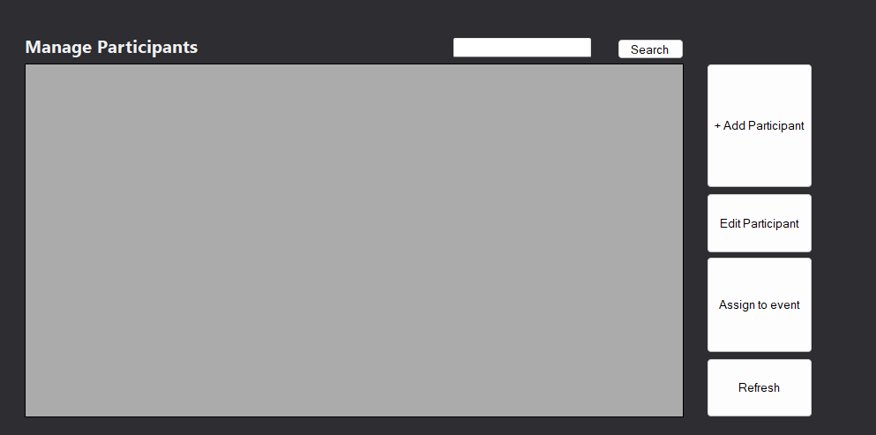

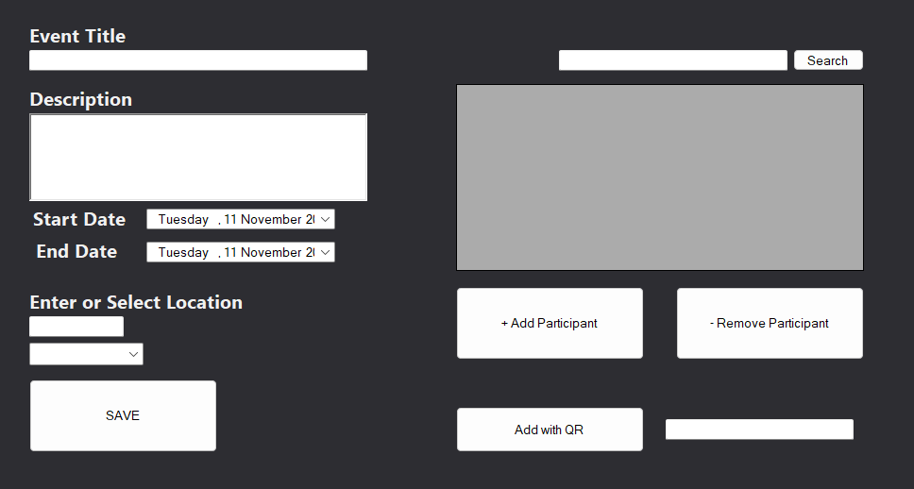

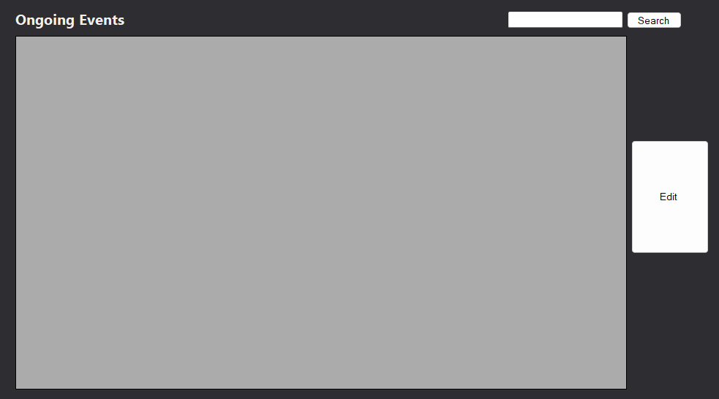

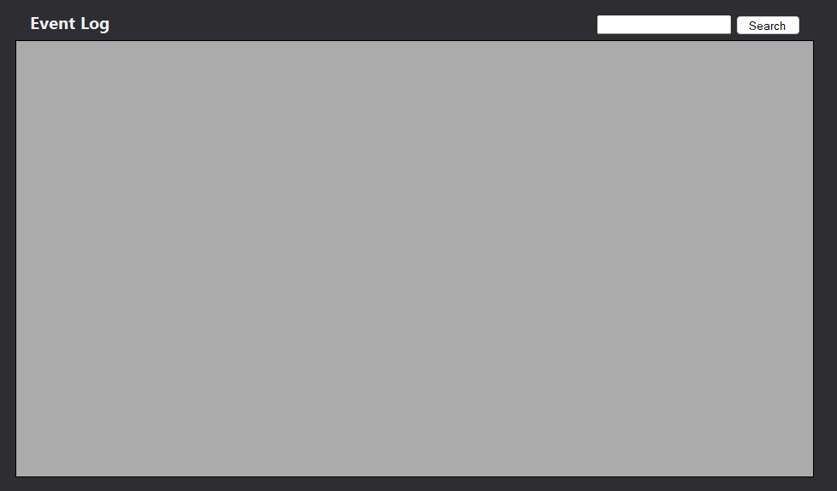

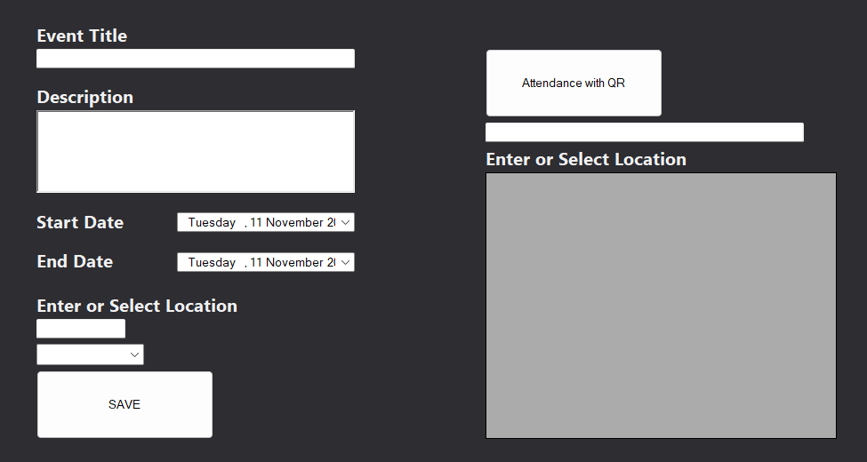





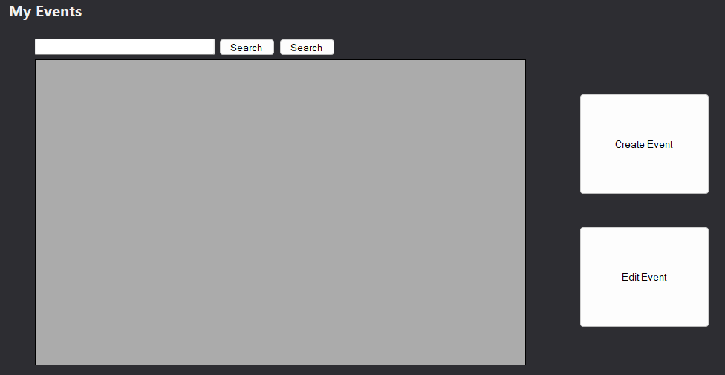

CHAPTER 3 – REVIEW OF RELATED LITERATURE

Related Research on Manual Attendance Tracking Problems
Traditional attendance tracking systems continue to present significant challenges for educational institutions worldwide. Organ (2024) highlights that manual attendance tracking processes have error rates ranging from 1-3%, leading to discrepancies in records that demand additional resources for correction. The research reveals that the average teacher spends approximately 10 minutes per day on attendance-related tasks, translating to over 400 hours of staff time per academic year in schools with 50 teachers.
Recent studies by IRJMETS (2025) demonstrate that conventional attendance management systems result in up to 20% inaccuracies, causing disruptions in tracking student participation. The research emphasizes that manual processes significantly impact classroom efficiency, consuming valuable instructional time as faculty members allocate 5–10 minutes per session for attendance. These findings align with IJARCCE (2024) research, which indicates that paper-based attendance records present numerous data integrity risks, including loss, transcription errors, and retrieval difficulties, with studies reporting 15–20% manual entry errors.
Furthermore, IRJMETS (2024) identifies that traditional methods lack real-time access to data, delaying institutional decisions and extending response time in addressing absenteeism trends. The study emphasizes that manual attendance systems are susceptible to fraud, including proxy attendance, where students mark presence on behalf of their peers, and lack authentication mechanisms that make unauthorized modifications possible.

Related Research on Event Management Challenges
Contemporary research in higher education event management reveals significant systemic challenges that impact institutional effectiveness. Brightly Software (2024) identifies that higher education institutions face broad challenges in event management, with campus events often catering to highly diverse audiences including students, parents, alumni, and donors. The research highlights key obstacles including limited resources for planning events involving hundreds or thousands of attendees, communication difficulties across departments and external service providers, and high-stakes pressure to achieve measurable return on investment.

IJRASET (2024) emphasizes that the efficient coordination of multifaceted activities and ensuring seamless communication with the student body have become pressing concerns for event organizers and college administrators. The study reveals that traditional methods, such as manual sign-ups and bulletin board announcements, are often inefficient and hinder student engagement due to fragmented communication, high administrative demands, and limited data-driven insights.

IRJMETS (2023) further corroborates these findings, indicating that the orchestration of college events can be a complex undertaking, with the increasing complexity and diversity of events presenting considerable challenges for event organizers. The research demonstrates that manual event management processes lead to inefficiencies in registration and monitoring processes, ultimately hindering decision-making and post-event evaluations.

Related Research on Technology-Driven Solutions
The integration of technology into attendance and event management systems has demonstrated substantial benefits for educational institutions. LACCEI (2024) presents transformative research on automated classroom attendance using machine learning-based recognition systems, emphasizing the need for more accurate, efficient, and reliable attendance tracking. The study demonstrates that automating attendance processes using advanced technology can improve operational efficiency, reduce errors, and ultimately provide a more productive learning environment.

Research by Nguyen-Tat et al. (2024) represents a groundbreaking approach to attendance tracking and management through the combination of Haar Cascade, OpenCV2, and NVIDIA Jetson Nano technologies. The study shows that automated systems significantly reduce administrative workload while improving accuracy in attendance records.

IJISRT (2025) demonstrates that AI-powered Smart Attendance Management Systems utilizing facial recognition technology enable automated attendance tracking with Local Binary Patterns Histogram algorithms, ensuring contactless, accurate, and efficient processes that minimize human intervention. The research indicates that such systems can process and verify student identities in real-time, substantially reducing administrative burden.

For event management specifically, Timely (2025) research reveals that AI-driven event management platforms designed for scalability support multi-language event promotion and automate workflows, enabling efficient management of academic programs and campus activities. The study demonstrates that centralized event management systems significantly enhance user engagement and administrative efficiency through three-layer architecture comprising user-friendly interfaces, robust backends, and efficient database structures.

Object-Oriented Programming and Database Integration
Contemporary research emphasizes the effectiveness of object-oriented programming approaches in educational software development. Phoenix NAP (2025) identifies that object-oriented databases integrate seamlessly with object-oriented programming languages, improving speed and productivity for developers working with complex data models. The research demonstrates that OODBs excel at handling complex data relationships without slow "joins" common in relational databases, making them particularly suitable for educational management systems.

Daily Dev (2024) research highlights that object-oriented databases offer unique advantages for handling complex data structures, with systems like ObjectDB being optimized for Java enterprise applications and providing advanced querying capabilities. The study indicates that such systems are ideal for applications requiring persistence, support for diverse data types, and frequent schema changes.

Microsoft documentation (2022) provides comprehensive evidence that Windows Forms applications backed by databases like MySQL enable efficient data management through Entity Framework Core, supporting full CRUD operations and seamless integration with educational workflows. The research demonstrates that such implementations provide robust, scalable solutions for institutional data management needs.

Alignment with Sustainable Development Goals (SDGs)
Educational technology implementations align significantly with global sustainability objectives. The United Nations (2025) emphasizes that SDG 4 ensures inclusive and equitable quality education and promotes lifelong learning opportunities for all. The framework specifically targets building and upgrading education facilities that provide safe, nonviolent, inclusive, and effective learning environments for all learners.

Campaign for Education (2022) research demonstrates that education is at the heart of the 2030 Agenda for Sustainable Development, serving as both a standalone goal and contributing to targets under other SDGs including health, growth, employment, and sustainable consumption. The study emphasizes that effective learning environments and the acquisition of relevant knowledge, skills, and competencies are fundamental to achieving these objectives.

UNDP (2025) research specifically highlights that SDG 4 aims to substantially increase the supply of qualified teachers and improve educational infrastructure through technology integration. The organization's findings indicate that modernized educational tools, including automated attendance and event management systems, contribute directly to creating more effective learning environments and improving institutional resource management.

Summary
The extensive literature review reveals consistent evidence supporting the development of integrated, technology-driven systems like Easy-E. Current research demonstrates that manual attendance tracking systems are inefficient, error-prone, and resource-intensive, with error rates reaching up to 20% and consuming significant instructional time. Event management challenges in higher education institutions include fragmented communication, limited real-time insights, and inefficient registration processes that hinder student engagement and administrative effectiveness.

Technology-driven solutions, particularly those employing object-oriented programming principles and database integration, offer substantial improvements in accuracy, efficiency, and user experience. AI-powered systems and automated workflows significantly reduce administrative burden while improving data reliability and institutional decision-making capabilities. Furthermore, such technological implementations align directly with Sustainable Development Goal 4 objectives, contributing to quality education through improved learning environments and resource management.

The convergence of these research findings provides strong justification for developing comprehensive, automated systems that integrate attendance tracking and event management functionalities within educational institutions.

RESULTS AND DISCUSSION

System Features and Functionalities
Feature | Description
Login and User Authentication | Authorized users, including Administrators, Organizers, and Viewers, can securely log in to access the system. User authentication ensures that data and functions are only available based on user roles, maintaining system security and controlled access.
Event Management | Administrators and Organizers can create and manage multi-day events. Each event includes start and end times with specified dates, venues, and descriptions, allowing structured scheduling and efficient organization of academic and institutional events.
Participant Registration | The system allows the registration of participants either manually or through QR Code. It validates input data and prevents duplicate entries, ensuring the accuracy and completeness of participant records.
Attendance Tracking | Attendance can be recorded manually through the system’s attendance form. Organizers can track daily participation, correct errors, and export attendance summaries for easy monitoring and documentation.
Graphical User Interface (GUI) | The interface, built using Windows Forms, provides an intuitive and organized layout. It includes features such as data grids, combo boxes, and buttons that simplify navigation and data interaction for all types of users.

Discussion
The Easy-E: Event Management System successfully streamlines the organization of multi-day events, addressing inefficiencies in manual attendance tracking and registration. By integrating user authentication and role-based access, the system ensures secure data handling and role-specific access to functionalities. The event management modules enable organizers to efficiently plan schedules and manage participants, while the attendance tracking feature significantly reduces time spent on manual checking. The system enhances productivity by automating participant registration and attendance tracking, reducing manual effort and improving data accuracy. Overall, Easy-E demonstrates improved accuracy, efficiency, and reliability in managing academic and institutional events, providing a user-friendly and functional solution for MMCM organizers and administrators.

Conclusion
The Easy-E System effectively achieved its goal of improving the efficiency and reliability of event management within MMCM. By integrating MySQL as a relational database and applying OOP principles in C#, the system demonstrated how structured software design can enhance performance, maintainability, and scalability. The user interface, developed with Windows Forms, proved to be user-friendly and responsive even in offline environments. Furthermore, the system’s automation of attendance tracking directly supports the United Nations Sustainable Development Goals (SDG 4: Quality Education and SDG 11: Sustainable Cities and Communities) by promoting organized, data-driven educational activities. Overall, Easy-E provides a practical and sustainable technological solution that reduces administrative workload and improves the quality of institutional event management.

Recommendations
To further enhance the capabilities and impact of the Easy-E system, future development may focus on creating a mobile or web-based version to improve accessibility for organizers and participants. Integrating cloud synchronization would allow seamless data sharing across multiple devices, while incorporating biometric or RFID-based attendance tracking could enhance accuracy and security. The addition of analytics dashboards for attendance patterns and participation trends would provide valuable insights for event organizers. It is also recommended that MMCM implement the system for managing campus events, seminars, and training programs, supported by short user training sessions and regular database backups to ensure data security and system continuity. Lastly, future researchers are encouraged to explore integration with the institution’s Learning Management System (LMS) or to expand the system for community-based event and volunteer tracking, further improving its analytical capabilities, user interface, and automation features to make it more adaptive and sustainable.

Sources:
Chowdhury, A., & Rahman, M. (2024). Challenges in manual attendance systems in universities: Time consumption, error rates, and limited real-time insights. International Academic Research Journal of Science and Engineering Technology, 12(5). https://iarjset.com/wp-content/uploads/2025/05/IARJSET.2025.125161.pdf
Srivastava, R. (2025). The role of technology in improving event management efficiency. International Policy Brief, March 2025. https://internationalpolicybrief.org/wp-content/uploads/2025/03/ARTICLE-3-3.pdf
Organ, P. (2024, February 15). The hidden costs: How manual attendance tracking damages schools and disrupts parent engagement. Orah. https://www.orah.com/blog/hidden-costs-of-manual-attendance
Creatrix Campus. (2025, July 29). Top 10 advantages of automatic student attendance systems. https://www.creatrixcampus.com/blog/top-10-advantages-automatic-student-attendance-system
SoftDunamis. (2025, January 15). Challenges of manual attendance marking and how to overcome. https://softdunamis.com/blog/manual-attendance-marking/
Attendly. (2024, October 20). The hidden costs of manual attendance tracking in after-school programs. https://attendly.com/blog/afterschool-programs/program-management/after-school-attendance-tracking/
Engagifii. (2024). Managing events in higher education. https://www.engagifii.com/engagifii-blogs/event-registration-challenges-solutions
EventX. (2025, April 15). Event attendance tracking: 5 methods for 2025 success. https://eventx.io/blog/event-attendance-tracking-5-methods-for-2025-success
International Journal of Advanced Research in Computer and Communication Engineering (IJARCCE). (2024). AttendEase: Simplifying manual attendance tracking. https://ijarcce.com/wp-content/uploads/2024/03/IJARCCE.2024.13330.pdf
Classter. (2025, February 20). Using school management systems to improve student attendance. https://www.classter.com/blog/edtech/school-management-systems/using-school-management-systems-to-improve-student-attendance/
AttendEase. (2024). Simplifying manual attendance tracking. International Journal of Advanced Research in Computer and Communication Engineering, 13(3). https://ijarcce.com/wp-content/uploads/2024/03/IJARCCE.2024.13330.pdf
ScienceDirect. (2021). Using barcode to track student attendance and assets in higher education. Procedia Computer Science, 181, 1-5. https://www.sciencedirect.com/science/article/pii/S187705092100778X
United Nations Development Programme. (2015). Sustainable Development Goals. https://www.undp.org/sustainable-development-goals
Okpala, E. N., Akomolafe, C. O., & Ikwu, D. O. (2024). Advancing sustainable development goals with educational technology. In A. Farzandipour & S. Panahbari (Eds.), Research Anthology on Inclusive Practices for Educators and Administrators in Special Education (pp. 1-18). IGI Global. https://www.igi-global.com/chapter/advancing-sustainable-development-goals-with-educational-technology/365323
-
Aldabagh, M. (2024). A review of students attendance management systems. EAJSE, 25(5), 034-042.
https://eajse.tiu.edu.iq/index.php/eajse/article/view/455
Brightly Software. (2024, December 2). Managing events in higher education. Brightly Software Blog.
https://www.brightlysoftware.com/blog/managing-events-higher-education
Bugingo, E. (2025). Enhancing face recognition attendance system utilizing real-time face tracking to ensure accuracy and reliability in attendance tracking. ScienceDirect, 25(4), 174-186.
https://www.sciencedirect.com/science/article/abs/pii/S254266052500174X
Campaign for Education. (2022, December 31). SDG 4 and targets.
https://campaignforeducation.org/en/key-frameworks/sdg-4-and-targets
Chaturvedi, A., Sharma, K., Dua, A., & Gupta, A. (2024). CU-Events: A comprehensive event management system for university. International Journal for Research in Applied Science and Engineering Technology, 12(11), 65020-65028.
https://doi.org/10.22214/ijraset.2024.65020
Daily Dev. (2024, September 2). Top 9 object-oriented database examples 2024.
https://daily.dev/blog/top-9-object-oriented-database-examples-2024
IJARCCE. (2024, March). AttendEase: Simplifying manual attendance tracking. International Journal of Advanced Research in Computer and Communication Engineering, 13(3), 221-228.
https://ijarcce.com/wp-content/uploads/2024/03/IJARCCE.2024.13330.pdf
IJISRT. (2025, April 25). AI-based smart attendance management system. International Journal of Innovative Science and Research Technology, 10(4), 723-730.
https://www.ijisrt.com/assets/upload/files/IJISRT25APR723.pdf
IJRASET. (2024, November 4). CU-Events: A comprehensive event management system for university. International Journal for Research in Applied Science and Engineering Technology, 12(11), 3374-3382.
https://www.ijraset.com/research-paper/cu-events-a-comprehensive-event-management-system-for-university
IRJMETS. (2023, November). College event management: A survey of management systems. International Research Journal of Modernization in Engineering Technology and Science, 5(11), 45827-45835.
https://www.irjmets.com/uploadedfiles/paper/issue_11_november_2023/45827/final/fin_irjmets1699242577.pdf
IRJMETS. (2024, June). Online attendance management system. International Research Journal of Modernization in Engineering Technology and Science, 6(6), 59624-59632.
https://www.irjmets.com/uploadedfiles/paper/issue_6_june_2024/59624/final/fin_irjmets1719592518.pdf
IRJMETS. (2025, May). Web-based student attendance management system. International Research Journal of Modernization in Engineering Technology and Science, 7(5), 3374-3382.
https://www.irjmets.com/upload_newfiles/irjmets70500125547/paper_file/irjmets70500125547.pdf
LACCEI. (2024). Automated classroom attendance using a machine learning-based recognition system. LACCEI 2024 Costa Rica Conference Proceedings, 676, 1-8.
https://laccei.org/LACCEI2024-CostaRica/papers/Contribution_676_final_a.pdf
Microsoft. (2022, August 24). Get started with Windows Forms - EF Core. Microsoft Learn.
https://learn.microsoft.com/en-us/ef/core/get-started/winforms
Nguyen-Tat, B. T., et al. (2024). Automating attendance management in human resources. ScienceDirect, 42(3), 429-445.
https://www.sciencedirect.com/science/article/pii/S2667096824000429
Organ, P. (2024, February 15). The hidden costs: How manual attendance tracking damages schools and disrupts parent engagement. Orah Blog.
https://www.orah.com/blog/hidden-costs-of-manual-attendance
Phoenix NAP. (2025, January 14). Object oriented database (OODB): Definition, features, and applications.
https://phoenixnap.com/kb/object-oriented-database
Sonkar, D. (2024, July). Automated attendance system using RFID and face recognition research paper. International Journal of Novel Research and Development, 9(7), 598-604.
https://ijnrd.org/papers/IJNRD2407062.pdf
Timely. (2025, January 2). Event management software for universities and colleges.
https://time.ly/markets/venue-event-management-software-for-universities-colleges/
United Nations. (2025, September 9). Goal 4: Education - United Nations Sustainable Development.
https://www.un.org/sustainabledevelopment/education/
United Nations Development Programme. (2025, August 31). Quality education - Goal 4.
https://www.undp.org/sustainable-development-goals/quality-education

Appendix

Login Screen
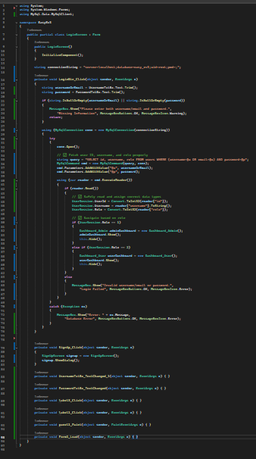

Dashboard Admin
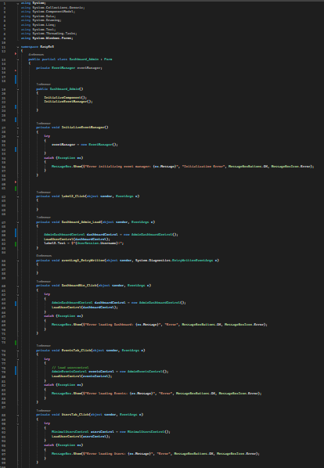

Database manager
